|  |  |  |  |  |
| --- | --- | --- | --- | --- |
| EWULogo.png | | **EAST WEST UNIVERSITY** | | |
| **Department of Computer Science and Engineering** | | |
| **B.Sc. in Computer Science and Engineering Program** | | |
| **Mid Term II Examination, Fall 2018** | | |
| **Course:** | | **CSE442 – Microprocessors and Microcontrollers, Section-1** | |  |
| **Instructor:** | | **Md. Nawab Yousuf Ali, PhD, Associate Professor, CSE Department** | |  |
| **Full Marks:** | | **20 (15 mark will be counted for final grading)** | |  |
| **Time:** | | **1 Hour and 20 Minutes** | |  |
| **Note:** There are FIVE questions, answer ALL of them. Course outcomes (CO), cognitive levels and marks of each question are mentioned at the right margin. | | | | |
| 1. | Design a RAM chip with all control signals having 1024 KB of memory location. | | [CO1, C3, 3] | |
| 2. | Design an interface between a memory 27512EPROM and Intel 8086 microprocessor using a NAND gate decoder. Calculate the memory location decoded by NAND gate. Determine the output of the NAND gate and show the inputs of the control signals for reading data. | | [ CO1, C3, 5] | |
| 3. | Analyze the diagram and determine the LED lights that will be glown by the given configuration of the toggle switches in Figure 1. Write the assembly language program for the output. Draw the output. | | [ CO2, C3, 4] | |
|  | **Figure 1. 7- Segment display** | |  | |
| 4 | Design an address multiplexer for DRAM that contains only 8 address inputs, where it should contain 16-the numbered required addressing 64KB memory locations. Determines the pins functions for the operations. | | [ CO2, C3, 3 ] | |
| 5. | Analyze the clock generator 8284A for 8086/8088 microprocessor given in Figure 2. Determine the output for the following operations in a tabular form as indicated below.   1. When F/C=0 2. When F/C=1  |  |  |  |  |  |  |  |  |  |  | | --- | --- | --- | --- | --- | --- | --- | --- | --- | --- | |  | **a** | **b** | **c** | **d** | **e** | **f** | **g** | **PCLK** | **CLK** | | a) |  |  |  |  |  |  |  |  |  | | b) |  |  |  |  |  |  |  |  |  | | | [CO2, C3, 5] | |

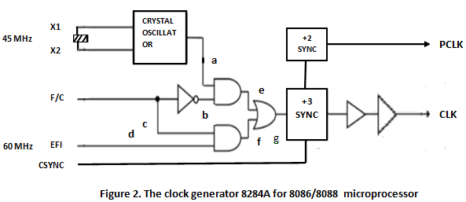

**EFI**